Name: Shreya Bhattacharjee

Roll no:8213

TYCS-A

Artificial Intelligence

DATE:

DAY:

TEACHER SIGN:

**Early Cancer Detection**

**AI in healthcare**

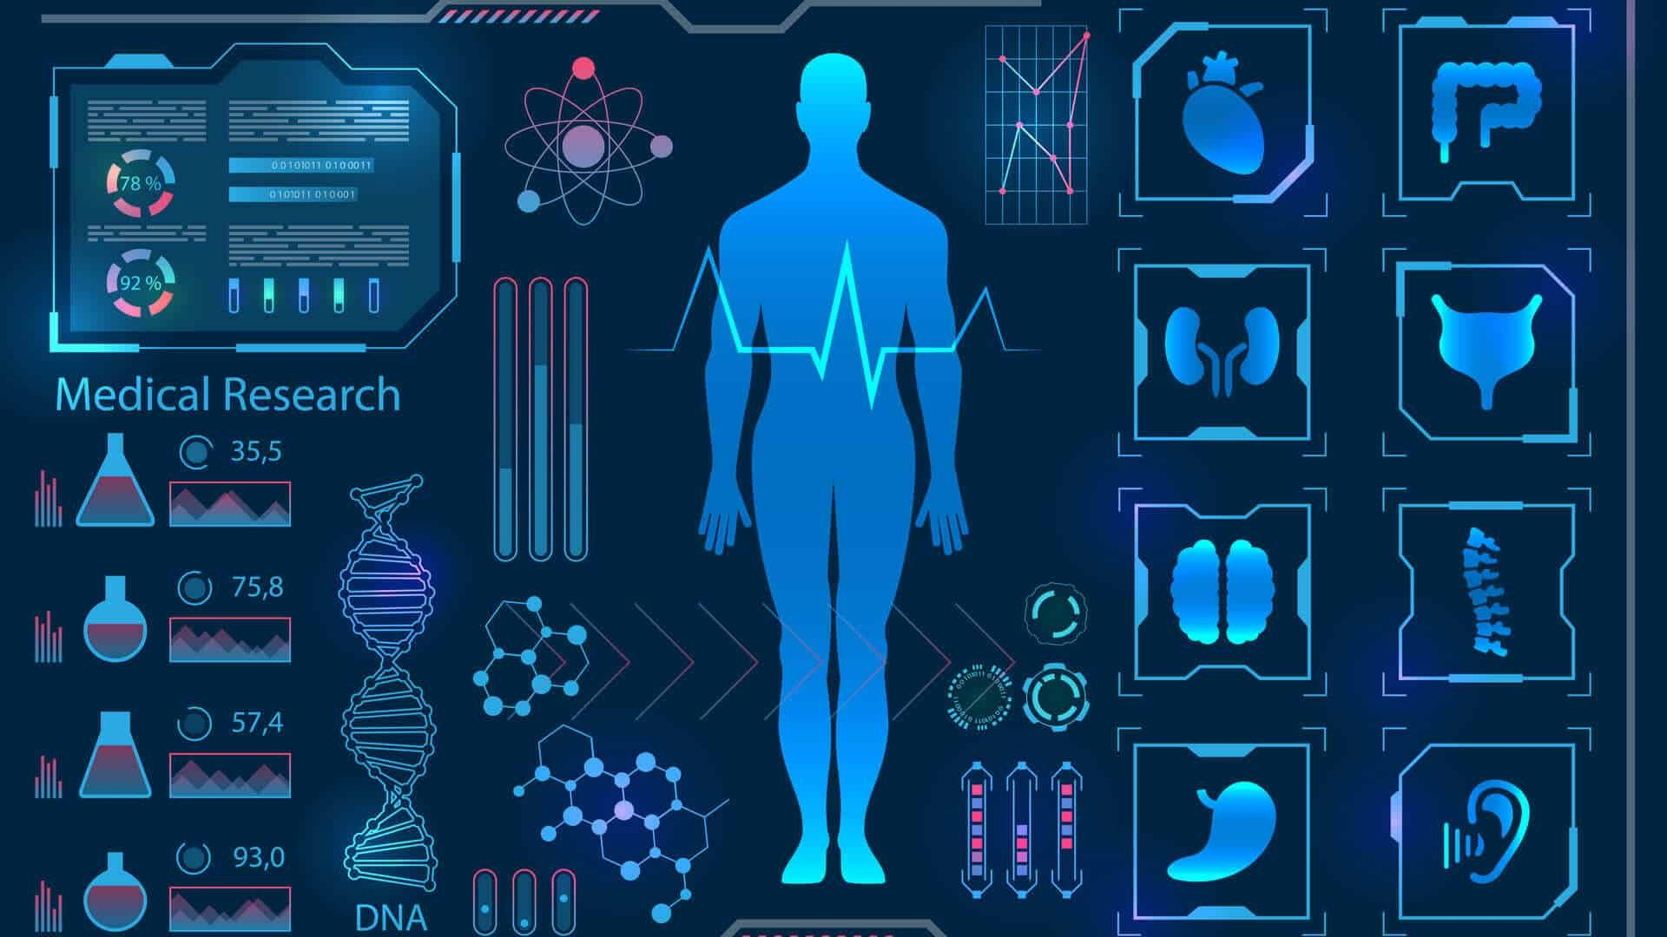

**Abstract**

Improving the proportion of patients diagnosed with early-stage cancer is a key priority of the World Health Organisation. In many tumour groups, screening programmes have led to improvements in survival, but patient selection and risk stratification are key challenges. In addition, there are concerns about limited diagnostic workforces, particularly in light of the COVID-19 pandemic, placing a strain on pathology and radiology services. In this review, we discuss how artificial intelligence algorithms could assist clinicians in (1) screening asymptomatic patients at risk of cancer, (2) investigating and triaging symptomatic patients, and (3) more effectively diagnosing cancer recurrence. We provide an overview of the main artificial intelligence approaches, including historical models such as logistic regression, as well as deep learning and neural networks, and highlight their early diagnosis applications. Many data types are suitable for computational analysis, including electronic healthcare records, diagnostic images, pathology slides and peripheral blood, and we provide examples of how these data can be utilised to diagnose cancer. We also discuss the potential clinical implications for artificial intelligence algorithms, including an overview of models currently used in clinical practice.

Finally, we discuss the potential limitations and pitfalls, including ethical concerns, resource demands, data security and reporting standards.

**INTRODUCTION**

The earlier detection of disease may lead to more cures or longer survival. This possibility has led to public health programs which recommend populations to have **periodic screening examinations for detecting specific chronic diseases**, for example, cancer, diabetes, cardiovascular disease and so on.

We discuss the potential applications of AI for early cancer diagnosis in symptomatic and asymptomatic patients, focussing on the types of data that can be used and the clinical areas most likely to see impacts in the near future.

**Background**

**AI was a term first coined at Dartmouth College in 1956**. Cognitive scientist Marvin Minsky was optimistic about the technology's future. The 1974-1980 saw government funding in the field drop, a period known as "AI winter", when several criticised progress in the field.

**Healthcare data**

Before AI systems can be deployed in healthcare applications, they need to be ‘trained’ through data that are generated from clinical activities, such as screening, diagnosis, treatment assignment and so on, so that they can learn similar groups of subjects, associations between subject features and outcomes of interest.

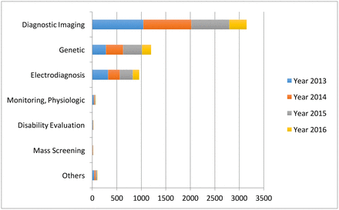

AI devices

The above discussion suggests that AI devices mainly fall into two major categories. The first category includes machine learning (ML) techniques that analyse structured data such as imaging, genetic and EP data. In the medical applications, the ML procedures attempt to cluster patients’ traits, or infer the probability of the disease outcomes.[17](https://svn.bmj.com/content/2/4/230#ref-17) The second category includes natural language processing (NLP) methods that extract information from unstructured data such as clinical notes/medical journals to supplement and enrich structured medical data.

The NLP procedures target at turning texts to machine-readable structured data, which can then be analysed by ML techniques.

**Disease focus**

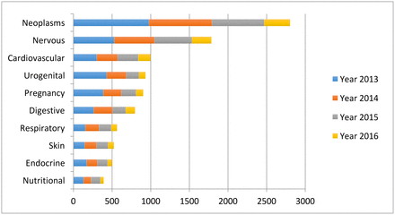

Cancer: Somashekhar *et al* demonstrated that the IBM Watson for oncology would be a reliable AI system for assisting the diagnosis of cancer through a double-blinded validation study.

Neurology: Bouton *et al* developed an AI system to restore the control of movement in patients with quadriplegia.[21](https://svn.bmj.com/content/2/4/230#ref-21) Farina *et al* tested the power of an offline man/machine interface that uses the discharge timings of spinal motor neurons to control upper-limb prostheses.

Cardiology: Dilsizian and Siegel discussed the potential application of the AI system to diagnose the heart disease through cardiac image.[3](https://svn.bmj.com/content/2/4/230#ref-3) Arterys recently received clearance from the US Food and Drug Administration (FDA) to market its Arterys Cardio DL application, which uses AI to provide automated, editable ventricle segmentations based on conventional cardiac MRI images.

Besides the three major diseases, AI has been applied in other diseases as well. Two very recent examples were Long *et al*, who analysed the ocular image data to diagnose congenital cataract disease,[24](https://svn.bmj.com/content/2/4/230#ref-24) and Gulshan *et al*, who detected referable diabetic retinopathy through the retinal fundus photographs.

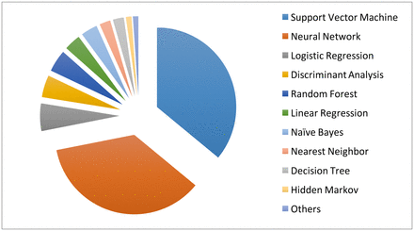

Clustering and principal component analysis (PCA) are two major unsupervised learning methods. Clustering groups subjects with similar traits together into clusters, without using the outcome information. Clustering algorithms output the cluster labels for the patients through maximising and minimising the similarity of the patients within and between the clusters.

**Body**

Early cancer diagnosis and artificial intelligence (AI) are rapidly evolving fields with important areas of convergence. In the United Kingdom, national registry data suggest that cancer stage is closely correlated with 1-year cancer mortality, with incremental declines in outcome per stage increase for some subtypes [[1](https://www.ncbi.nlm.nih.gov/pmc/articles/PMC8946688/#B1-cancers-14-01524)]. Using lung cancer as an example, 5-year survival rates following resection of stage I disease are in the range of 70–90%; however, rates overall are currently 19% for women and 13.8% for men [[2](https://www.ncbi.nlm.nih.gov/pmc/articles/PMC8946688/#B2-cancers-14-01524)]. In 2018, the proportion of patients diagnosed with early-stage (I or II) cancer in England was 44.3%, with proportions lower than 30% for lung, gastric, pancreatic, oesophageal and oropharyngeal cancers .Early diagnosis is recognised as a key priority by a number of organisations, including the World Health Organisation (WHO) and the International Alliance for Cancer Early Detection (ACED).

Patient selection and risk stratification are key challenges for screening programmes. AI algorithms, which can process vast amounts of multi-modal data to identify otherwise difficult-to-detect signals, may have a role in improving this process in the near future [[8](https://www.ncbi.nlm.nih.gov/pmc/articles/PMC8946688/#B8-cancers-14-01524),[9](https://www.ncbi.nlm.nih.gov/pmc/articles/PMC8946688/#B9-cancers-14-01524),[10](https://www.ncbi.nlm.nih.gov/pmc/articles/PMC8946688/#B10-cancers-14-01524)]. Moreover, AI has the potential to directly facilitate cancer diagnosis by triggering investigation or referral in screened individuals according to clinical parameters, and automating clinical workflows where capacity is limited [[11](https://www.ncbi.nlm.nih.gov/pmc/articles/PMC8946688/#B11-cancers-14-01524)].

In this review, we discuss the potential applications of AI for early cancer diagnosis in symptomatic and asymptomatic patients, focussing on the types of data that can be used and the clinical areas most likely to see impacts in the near future.

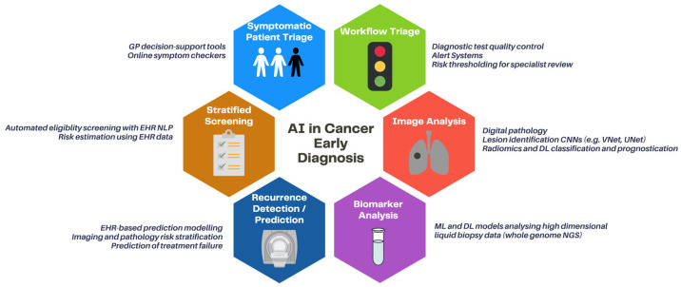

**CURRENT WORK OF AI IN HEALTHCARE**

 AI in healthcare can enhance preventive care and quality of life, produce more accurate diagnoses and treatment plans, and lead to better patient outcomes overall. AI can also predict and track the spread of infectious diseases by analyzing data from a government, healthcare, and other sources. As a result, AI can play a crucial role in global public health as a tool for combatting epidemics and pandemics.

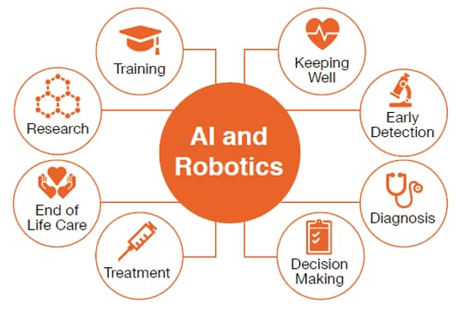

AI and robotics in healthcare is vast. Just like in our every-day lives, AI and robotics are increasingly a part of our healthcare eco-system.

We have highlighted eight ways that showcase how this transformation is currently underway.

EARLY DETECTION

AI is already being used to detect diseases, such as cancer, more accurately and in their early stages. According to the American Cancer Society, a high proportion of mammograms yield false results, leading to 1 in 2 healthy women being told they have cancer. The use of AI is enabling review and translation of mammograms 30 times faster with 99% accuracy, reducing the need for unnecessary biopsies

KEEPING WELL

One of AI's biggest potential benefits is to help people stay healthy so they don't need a doctor, or at least not as often. The use of AI and the Internet of Medical Things (IoMT) in consumer health applications is already helping people.

DIAGONOSIS

IBM’s Watson for Health is helping healthcare organizations apply cognitive technology to unlock vast amounts of health data and power diagnosis.  Watson can review and store far more medical information – every medical journal, symptom, and case study of treatment and response around the world – exponentially faster than any human.

Decision making

Improving care requires the alignment of big health data with appropriate and timely decisions, and predictive analytics can support clinical decision-making and actions as well as prioritise administrative tasks.

Treatment

Robots have been used in medicine for more than 30 years. They range from simple laboratory robots to highly complex surgical robots that can either aid a human surgeon or execute operations by themselves. In addition to surgery, they’re used in hospitals and labs for repetitive tasks, in rehabilitation, physical therapy and in support of those with long-term conditions.

END OF LIFE CARE

Robots have the potential to revolutionise end of life care, helping people to remain independent for longer, reducing the need for hospitalisation and care homes. AI combined with the advancements in humanoid design are enabling robots to go even further and have ‘conversations’ and other social interactions with people to keep aging minds sharp.

Research

The path from research lab to patient is a long and costly one. According to the California Biomedical Research Association, it takes an average of 12 years for a drug to travel from the research lab to the patient. Only five in 5,000 of the drugs that begin preclinical testing ever make it to human testing and just one of these five is ever approved for human usage. Drug research and discovery is one of the more recent applications for AI in healthcare. By directing the latest advances in AI to streamline the drug discovery and drug repurposing processes there is the potential to significantly cut both the time to market for new drugs and their costs.

Training

AI allows those in training to go through naturalistic simulations in a way that simple computer-driven algorithms cannot. The advent of natural speech and the ability of an AI computer to draw instantly on a large database of scenarios, means the response to questions, decisions or advice from a trainee can challenge in a way that a human cannot. And the training programme can learn from previous responses from the trainee, meaning that the challenges can be continually adjusted to meet their learning needs.And training can be done anywhere; with the power of AI embedded on a smartphone, quick catch up sessions, after a tricky case in a clinic or while travelling, will be possible.

Video of AI in Healthcare

https://youtu.be/-NTydicSqV8

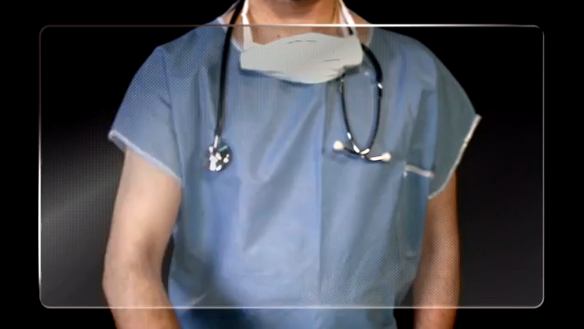

Conclusion

We reviewed the motivation of using AI in healthcare, presented the various healthcare data that AI has analysed and surveyed the major disease types that AI has been deployed. The first guidance classifies AI systems to be the ‘general wellness products’, which are loosely regulated as long as the devices intend for only general wellness and present low risk to users. The second guidance justifies the use of real-world evidence to access the performance of AI systems. Lastly, the guidance clarifies the rules for the adaptive design in clinical trials, which would be widely used in assessing the operating characteristics of AI systems. Not long after the disclosure of these guidances, Arterys’ medical imaging platform became the first FDA-approved deep learning clinical platform that can help cardiologists to diagnose cardiac diseases.[23](https://svn.bmj.com/content/2/4/230#ref-23)

The second hurdle is data exchange. In order to work well, AI systems need to be trained (continuously) by data from clinical studies. However, once an AI system gets deployed after initial training with historical data, continuation of the data supply becomes a crucial issue for further development and improvement of the system. Current healthcare environment does not provide incentives for sharing data on the system. Nevertheless, a healthcare revolution is under way to stimulate data sharing in the USA.[69](https://svn.bmj.com/content/2/4/230#ref-69) The reform starts with changing the health service payment scheme. Many payers, mostly insurance companies, have shifted from rewarding the physicians by shifting the treatment volume to the treatment outcome.

REFERENCES

<https://svn.bmj.com/content/2/4/230>

https://www.sciencedaily.com/releases/2021/08/210820135346.htm

https://search1.me/search?q=AI%20in%20healthcare%20demo%20video#gsc.tab=0&gsc.q=AI%20in%20healthcare%20demo%20video&gsc.page=1

<https://en.wikipedia.org/wiki/Artificial_intelligence_in_healthcare>

PROVIDE ALL THE CITATIONS